Create a post on Facebook :

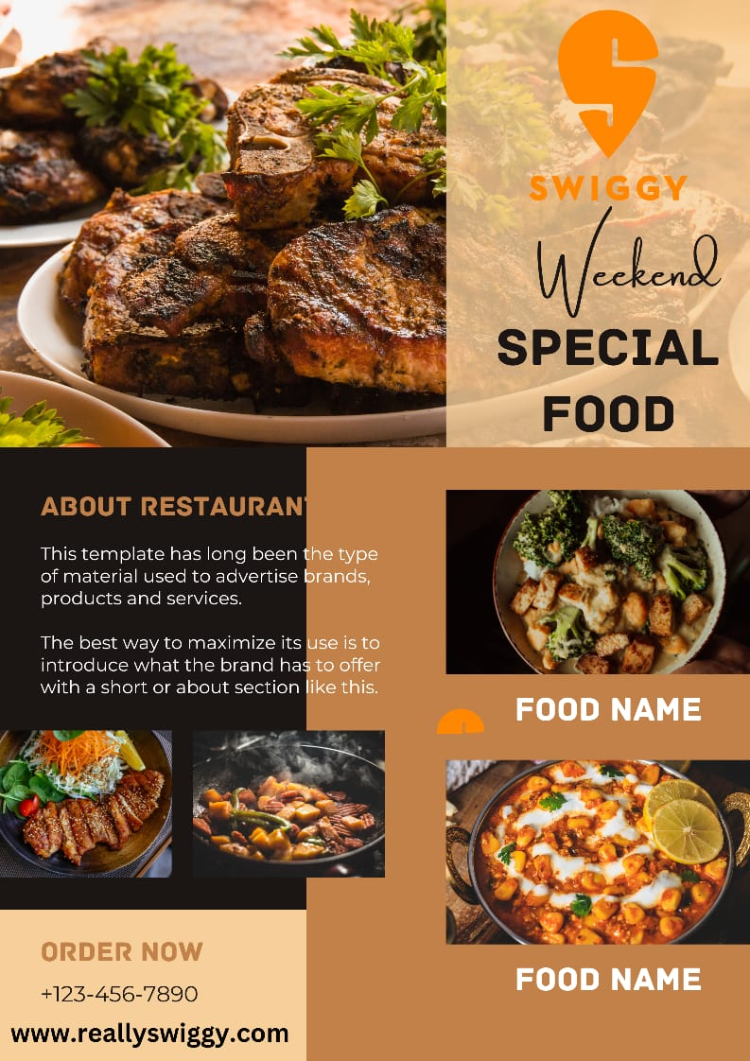

Link:https://www.facebook.com/share/v/4p48GzeQxP4yMJ67/?mibextid=Nif5oz